UGANDA MARTYRS UNIVERSITY-NKOZI.
Faculty of science.

COURSE UNIT: MOBILE COMPUTING AND NETWORKS
LECTURER’S NAME: MR. KASOZI BRIAN
GROUP A.
STUDENTS NAME REG NO.

- Ronald Ssentongo 2020-B071-12238

Book Store Cave
- Introduction
In a world where mobile applications have become an integral part of our daily lives, BookCave aims to revolutionize the way avid readers like Sarah discover new books. With over 60% of the global population relying on mobile devices for various tasks, BookCave will cater to the needs of book enthusiasts who desire a seamless and enriching reading experience, even when offline.
The Bookstore App is meant to ease the pain that book store owners have had to face with operating computer systems from 90s. Keeping this in mind we designed an app which can be used on a portable device like mobile with a simple and easy to use interface.

  - . Background/ Problem Statement

In the digital age, the proliferation of mobile technology has transformed countless aspects of daily life, including how we engage with literature.
BookCave emerges as a beacon for bibliophiles, a sanctuary where the love for books is not limited by connectivity. With over 60% of the global population owning mobile devices, BookCave is not just an application; it's a revolution in mobile reading experiences.

BookCave is designed to cater to the modern reader's dilemma—finding that perfect book in a sea of endless choices. It addresses the unique challenge faced by Sarah, an archetype of our target audience: an avid reader seeking to discover new literary worlds while on the go. Whether she is commuting on a train or nestled in a remote location, BookCave offers her a gateway to an extensive library of books, accessible anytime, anywhere.

The app stands out by providing an offline mode, a feature that allows readers like Sarah to download and explore content without the need for a constant internet connection. This capability ensures that the pursuit of knowledge and entertainment through reading is uninterrupted, fostering a seamless user experience.

BookCave is not just about reading; it's about discovery. It leverages sophisticated algorithms to recommend books based on user preferences, reading habits, and even moods. This personalized approach ensures that every recommendation is a potential new favorite, making BookCave a personal librarian in the palm of your hand.
The choice of JAVA and KOTLIN for the development of BookCave's business logic underscores our commitment to creating a robust, scalable, and secure application. These technologies enable us to build a platform that not only meets the current demands of mobile application users but also anticipates future trends and functionalities.

In essence, BookCave is more than an app—it's a haven for readers, a place where the love for books is nurtured, and the quest for new stories is endless. It's where every reader can find their next adventure, lesson, or escape. BookCave is where your reading journey begins.

1.2. Working of the Project

In this android system, the admin can log in to view the list of users using the app. The admins are able to block and unblock any user they want. They can also view the list of the books added by the users for auction.

The user here can register first to log in to their account. They can view their profile after they log in. They can also change the password whenever they want. If the user is interested in buying a book, they can search for the name or description of the book added by the other users. They can add or remove any book from the cart. After buying a particular book, the user can check out the list, details and status of the book they have purchased. The user can hold an online auction if they wish to sell a specific collection of unique and authentic books or comics that are not widely available or only come in a limited number of prints. They can add, update, view and delete any book they want. The other users interested can bid on the auctioned book. The user can view the bid list and the winner of the auction as well. Similarly, the user can bid on auctions put up by others as well.

In this project, the front end involves XML and the back end involves SQLite. The IDE used is Android Studio.

1.3. Objective
The primary objective of BookCave is to develop a user-friendly mobile application that allows users to explore and discover new books tailored to their interests, without the need for an active internet connection.

1.4. Target Audience
Our target audience is book lovers who enjoy reading across various genres and are looking for a convenient way to find their next read, especially during times when they are offline, such as during travel.

Advantages

- The user can buy or sell any book anytime, anywhere without much hassle.
- People can get access to books they couldn’t find anywhere else.
- The user can sell or auction off the books they don’t need anymore.
- Easy and simple process to share books without wasting much physical energy.

- System Description

The system comprises 1 major module with their sub-modules as follows:
ADMIN:
- Login
- The admin can log in to the account with an ID and password.
- 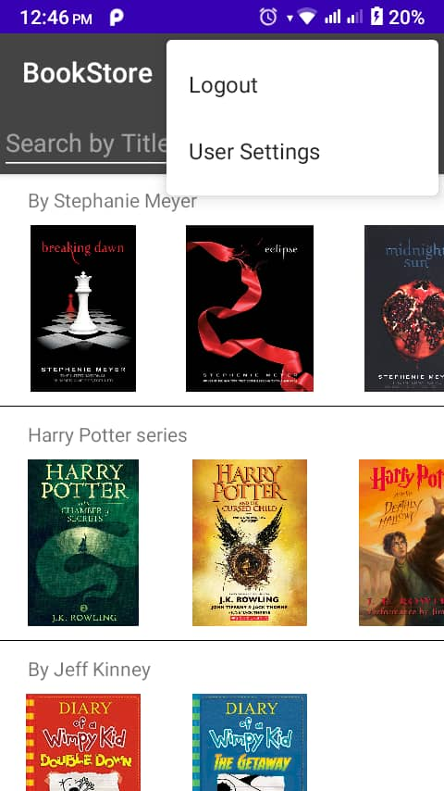
- View Users
- The admin can view the list of users.
- The admin is allowed to block and unblock users as necessary.

- 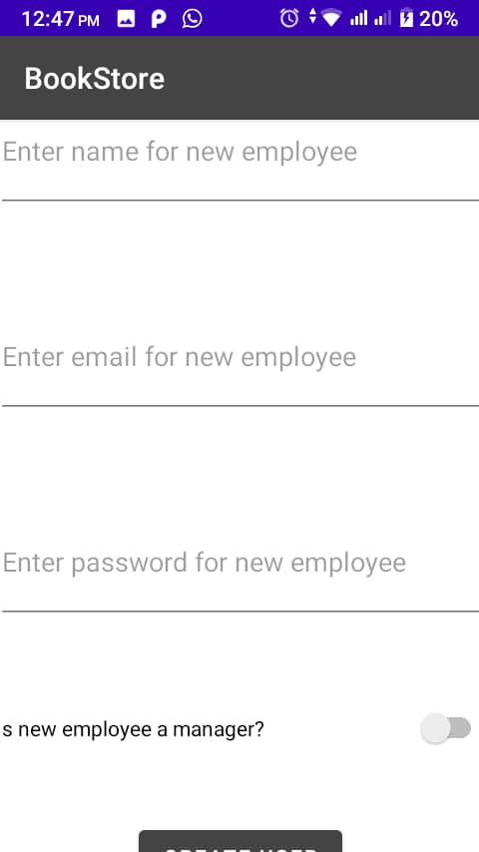

- View Books
- The admin can view the list of books added by the users.
- 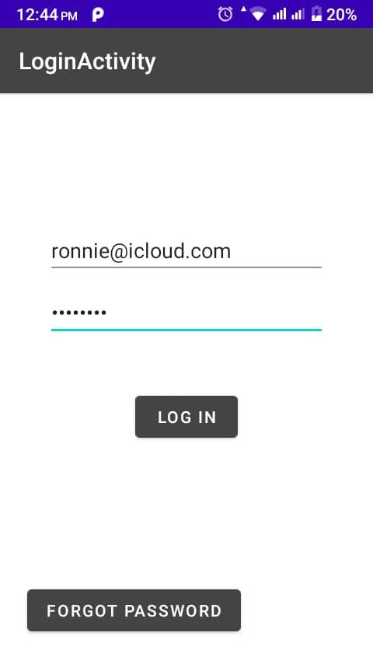

USER:
- Login
- The user can log into the account with an ID and password.
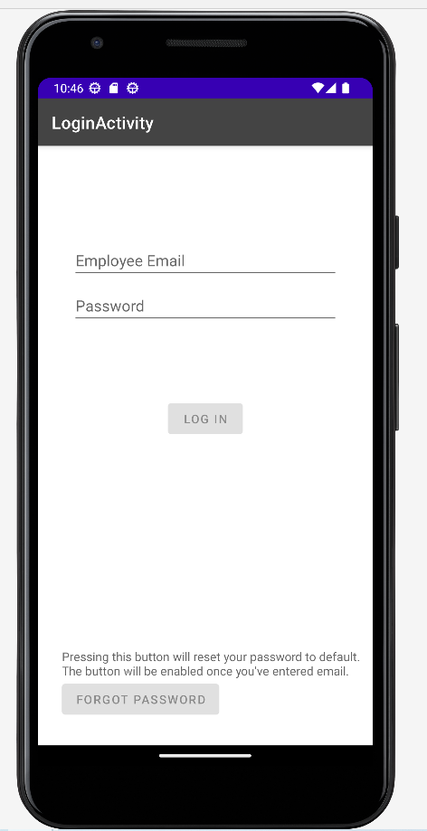
- Profile
- The user can view their profile on the account.

- Change Password
- The user can change the passwords as per their choice.
- My Books
- The user can add, search, update and view the books that they want to sell.
- 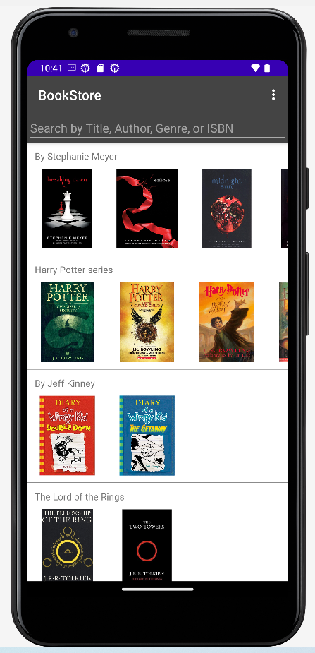
- 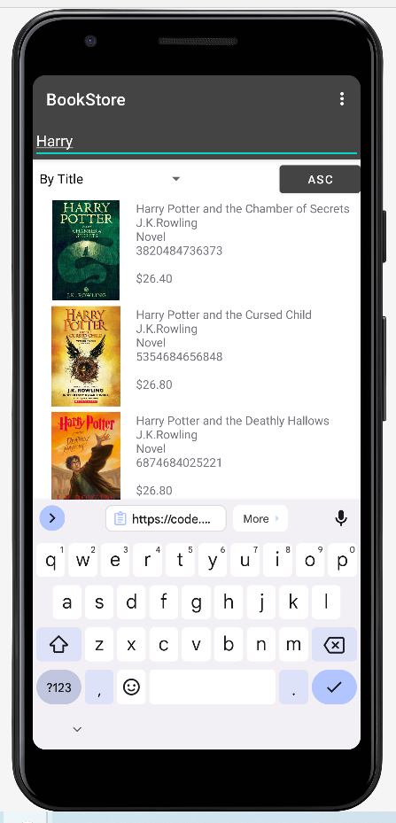
- Buy Books
- The user can search for any book they want to buy and read the book descriptions added by the other users.
- The user can add the book to their cart for the purchase.
Orders
- Purchases
- The user can view the list, details and status of the books they have placed an order for.
- 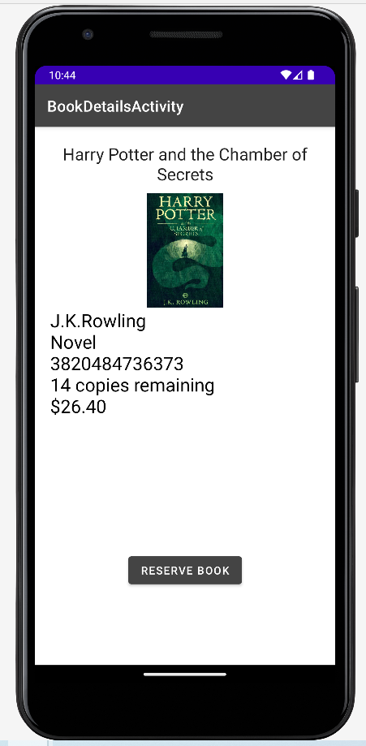
- Sales
- The user can view the list, details and status of the books they have sold to others.
- They can also change the status of the orders placed by others.
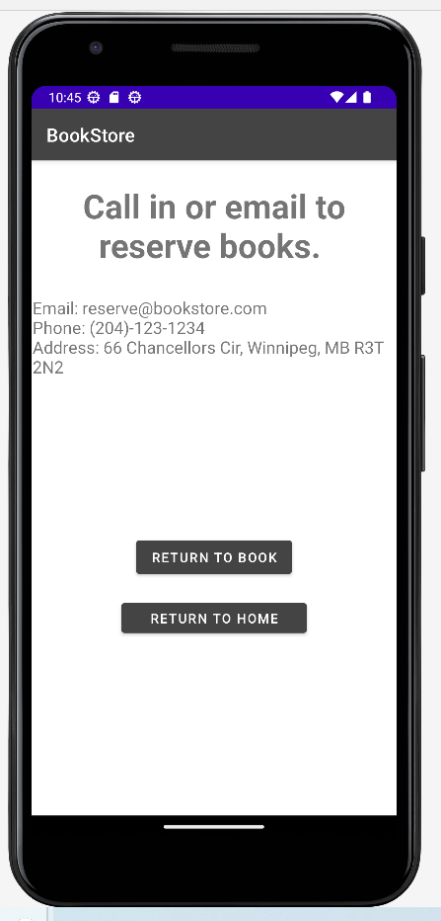

Auction
- My Auction
- The user can add, update, delete and view any book they want to auction off.
- The user can view the bid lists and the winner of the auction.
- 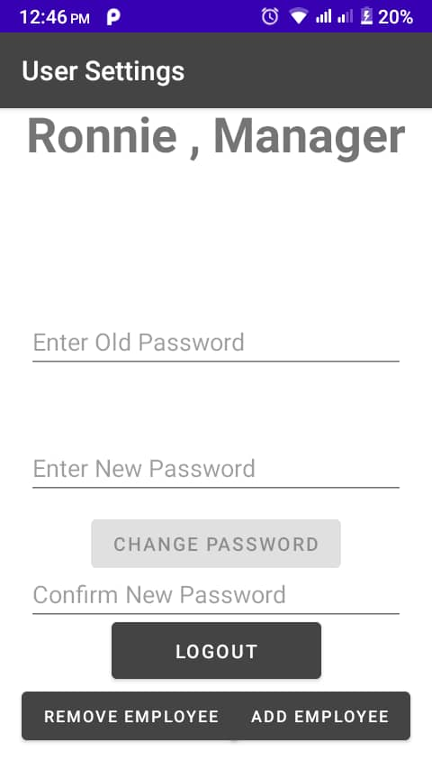
- View Auction
- The user can view the book auctions other users have added.
- If the user is interested, they can bid on the auction.
- The user can view the bids list & winner of the auction.
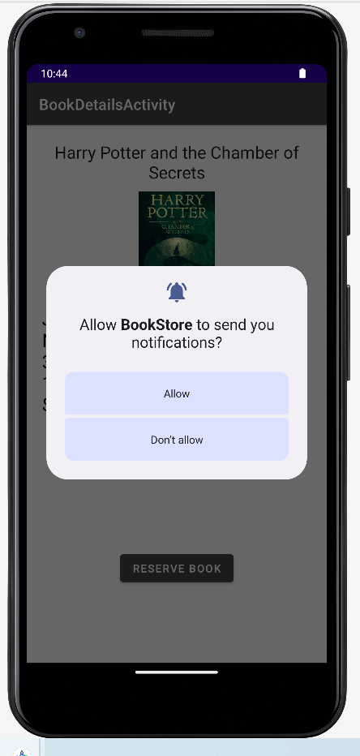

- Project Life Cycle

The waterfall model is a classical model used in the system development life cycle to create a system with a linear and sequential approach. It is termed a waterfall because the model develops systematically from one phase to another in a downward fashion. The waterfall approach does not define the process to go back to the previous phase to handle changes in requirements. The waterfall approach is the earliest approach that was used for software development.

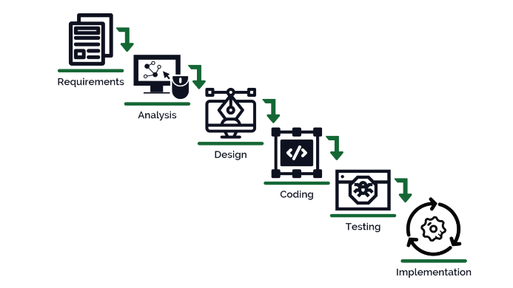

  - System Requirements

- Hardware Requirement

- Laptop or PC
- Windows 7 or higher
- I3 processor system or higher
- 8 GB RAM or higher
- 100 GB ROM or higher
- Android Phone (6.0 and above)

- Software Requirement

- Laptop or PC
- Android Studio
- Azure Data Studio

3.2 Limitations/Disadvantages

- Internet is mandatory to use the app.
- Adding any wrong information about the books can lead to low sales or purchases.
3.3 Modifications
- User Interface Redesign: Based on user feedback, the user interface could be simplified to enhance navigability and reduce cognitive load. Larger fonts and buttons, along with a more intuitive layout, could significantly improve the user experience.
- Enhanced Offline Capabilities: While the app currently allows for offline browsing of pre-downloaded content, expanding this feature to include more interactive elements like note-taking or highlighting could greatly benefit users.
- Performance Optimization: Revisiting the codebase to optimize performance, especially during startup and book loading times, could lead to a smoother experience for the user.
3.4. Alternatives
- Cross-Platform Development: Instead of using JAVA or KOTLIN exclusively, considering a cross-platform framework like Flutter or React Native could potentially reduce development time and facilitate easier updates across multiple platforms.
- Cloud Syncing: While the app is designed for offline use, implementing a cloud syncing feature for when users do have internet access could ensure seamless transition between devices and data backup.
3.5 Lessons Learned
Development Process:
- User-Centric Design: One of the key lessons learned is the importance of keeping the user at the center of the design process. Regular user testing and feedback are crucial for creating an app that truly meets the needs of the target audience.
- Agile Methodology: Adopting an agile approach to development allowed for flexibility and adaptability in the face of changing requirements and user preferences.
3.6. Technical Insights
- Code Quality: Ensuring high code quality from the start can significantly reduce the time spent on debugging and refactoring later on.
- Scalability: Designing the app with scalability in mind has been essential. It's important to anticipate future growth and make architectural decisions that allow for easy expansion of features.

3.7. Successes and Setbacks
- Effective Planning: One of the successes was the thorough planning phase, which laid a strong foundation for the development process.
- Underestimating Tasks: A setback was underestimating the time required for certain tasks, particularly those related to implementing the offline functionality, which proved to be more complex than initially thought.

Application

- It aims to provide a platform for any user, who has a book that is not needed anymore and would like to sell it to another user that may have the need for it.

